3. Revisit the Series B classification before finalizing the developmental-stage measure
According to Phan et al.(2026) and DeSantola et al., (2023), we classified firms as Seed/pre-Series, Series A, Series B, or Series C+ and estimated VD-by-stage interactions, followed by average VD effects within each stage. The negative association is strongest at Series C+.

Pham et al. (2026, Review of Finance) explain their approach to classifying financing rounds when series information is missing in PitchBook: “a small fraction of rounds in Pitchbook have no clear series information. For these cases, we approximate the series label of a round by first using available information from its lead or lag round (e.g., a round is assumed to be a Series B round if its previous round is already identified as a Series A), and then by the order of the round (e.g., the first round is Seed, the second round is Series A, etc.)”
DeSantola et al. (2023, Organization Science) operationalize firms' developmental progress using completed VC financing rounds and IPO milestones: “Here, we measured the number of milestones passed based on the completion of VC rounds and/or an initial public offering. This variable ranged from zero to four. We coded each of the first three formal rounds of VC finance (series A, B, and C) as one, two, and three, respectively. Firms that had completed an initial public offering at time t were coded as four. Here, we build on prior work that analytically treats raising a round of VC financing and undertaking an IPO as incremental increases in development progress.”

Building on these studies, we classified firms into four developmental stages at the time of VD financing: Seed/pre-Series, Series A, Series B, and Series C+. We reported regressions in Table 4-1 and 4-2 for average marginal effect.

4. Revisit the pseudo-treatment-year construction
Table A16 summarizes time from founding to first VC, founding to first VD, and first VC to VD in the pre-matching sample.

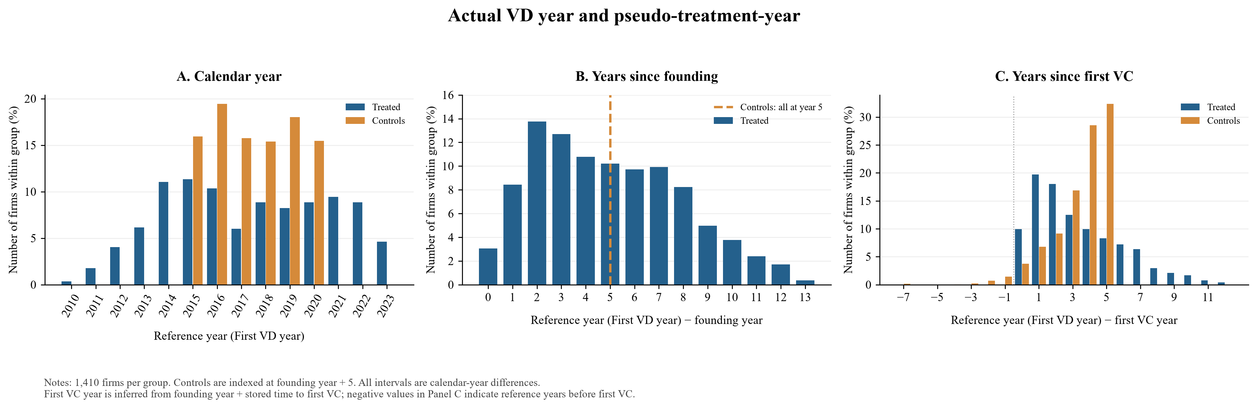

5. Explore a staggered DiD/event-study design
Tables 9–12 and Figures A3–A5 estimate Callaway–Sant’Anna staggered DiD models on annual patent outcomes, using first VD year as treatment timing and comparing never-treated with not-yet-treated controls. Event-study estimates span years −4 to +4 and examine pre-treatment patterns, post-treatment dynamics, and heterogeneity.

6. Take the VD amount/intensity analysis seriously
Tables 13 and 14 use post-VD patenting to initial VD amount and VD relative to the preceding equity round.

7. Use lender identities primarily to validate the VD measure

Classification | Firms | % of VD-backed firms | Firms with names
Specialized VD providers | 134 | 9.5 | 18.8%
Banks with established venture/startup lending | 106 | 7.5 | 14.8%
Other identifiable institutional lenders | 163 | 11.6 | 22.8%
Ambiguous cases | 311 | 22.1 | 43.6%
Subtotal: investor identity available | 714 | 50.6 | 100.0%
Investor names missing | 696 | 49.4
Total VD-treated firms | 1,410 | 100.0
We classified the 714 matched VD firms with available investor names into specialized providers, venture-lending banks, other institutional lenders, and ambiguous cases. The other 696 firms remain unidentified.

8. Strengthen the matching diagnostics if we retain PSM
Table A15 and Figures A1–A2 report before AND after matching comparisons, pscore overlap, and a love plot of covariate balance. Table A15 is the current balance table, replacing the A9 cross-reference above.

9. Look for more direct measures of changes in startup innovation
Tables A7–A14 add patent-text readability, patents in new versus existing CPC domains, entry into new CPC classes, backward-citation breadth, and self-citations over the three-year post-reference window. New-domain measures use distinct measures of innovation content, while technological distance and originality are not reported due to insignificance.

10. Rework the downstream financing analysis, but keep it supportive rather than central
Table A3 separates equity-raising probability using LPM, next-round hazard using cox hazard model, and next-round log amount conditional on raising.

11. Move employee and revenue analyses to the Appendix
Tables A4–A6 places employee regressions and pooled/annual revenue comparisons in the Appendix.

12. Keep the interpretation of M&A/IPO and downstream outcomes cautious
Table 8 reports separate Cox models for M&A, IPO, and defunct outcomes.

